Automated Frequency Detection Tool Tutorial

This tutorial walks through step-by-step how to use the frequency detection tool, which can only be run with outputs from the seep detection tool.

1. Open ArcMap.
2. Once ArcMap has loaded, click on the “Catalog” icon in the upper middle of the screen. 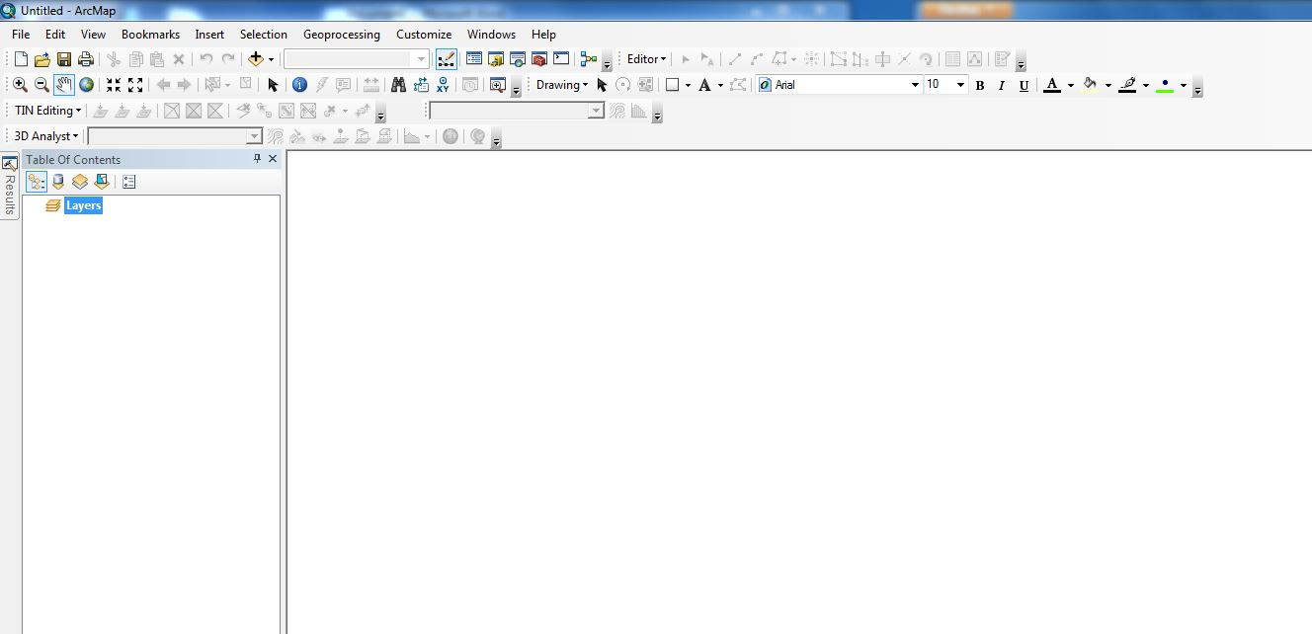

C:\Users\sbarron\Dropbox\JPL - Summer 2013\CA_MS Disasters and Water Resources\Weekly Science Advisor Meetings\Scott's Images\Tutorial_3.JPG

1. Once selected, locate the folder where the Frequency Detection tool is located.

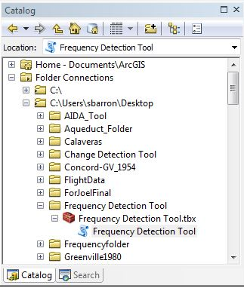

1. Once located, double click on the “Frequency Detection Tool” script, located directly under the “Frequency Detection Tool.tbx” toolbox.
2. This should now bring up the input menu for the tool, which looks like this:

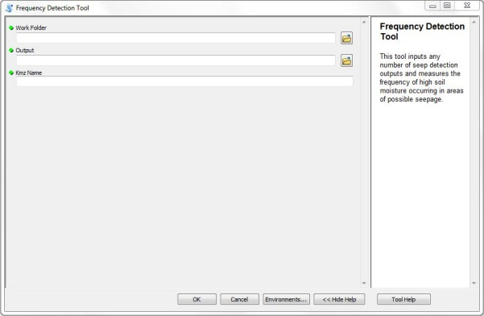

Notice the green dots to the left of the input names. These denote fields that are required by the tool.

1. Begin with the field “Work Folder”. This is the name of the folder where all of your input seep data is located. This folder should be the same one designated as the “Frequency/Change Detection Folder” from the seep detection tool. Locate this folder and set is as your “Work Folder”.

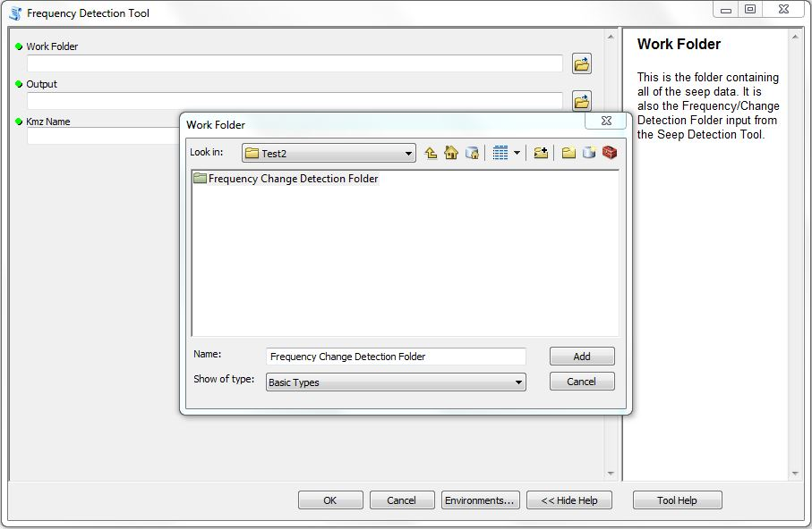

Once selected, click the “Add” button.

1. The second input is “Output”. This is the name and location you would like to assign to the frequency detection file generated by the tool.
2. The last input is “Kmz Name”. This is the name of the Frequency Detection file that will be compatible with Google Earth. Unlike other file name inputs, instead of selecting the name and file path, all you need to do here is type whatever you would like to call the file, for example: Kmz\_file. It is a good idea, for simplicity’s sake, to use the same name as your output.
3. If you are satisfied with the inputs, then click “OK” and let the tool run. Depending on your computer’s capabilities, it should take a few minutes.
4. Once the tool is completed, you can view the results in one of two ways. You can view the file in ArcMap, which should be displayed on the screen as soon as the tool has run successfully. If the file is not displayed, simply click on the “Add Data” button as shown below, and find the file name and location used for the “Output” parameter. You can also view the data by opening Google Earth, and displaying the kmz generated by the tool, which should be located in your “Work Folder”.



C:\Users\sbarron\Dropbox\JPL - Summer 2013\CA_MS Disasters and Water Resources\Weekly Science Advisor Meetings\Scott's Images\Tutorial_10.JPG

